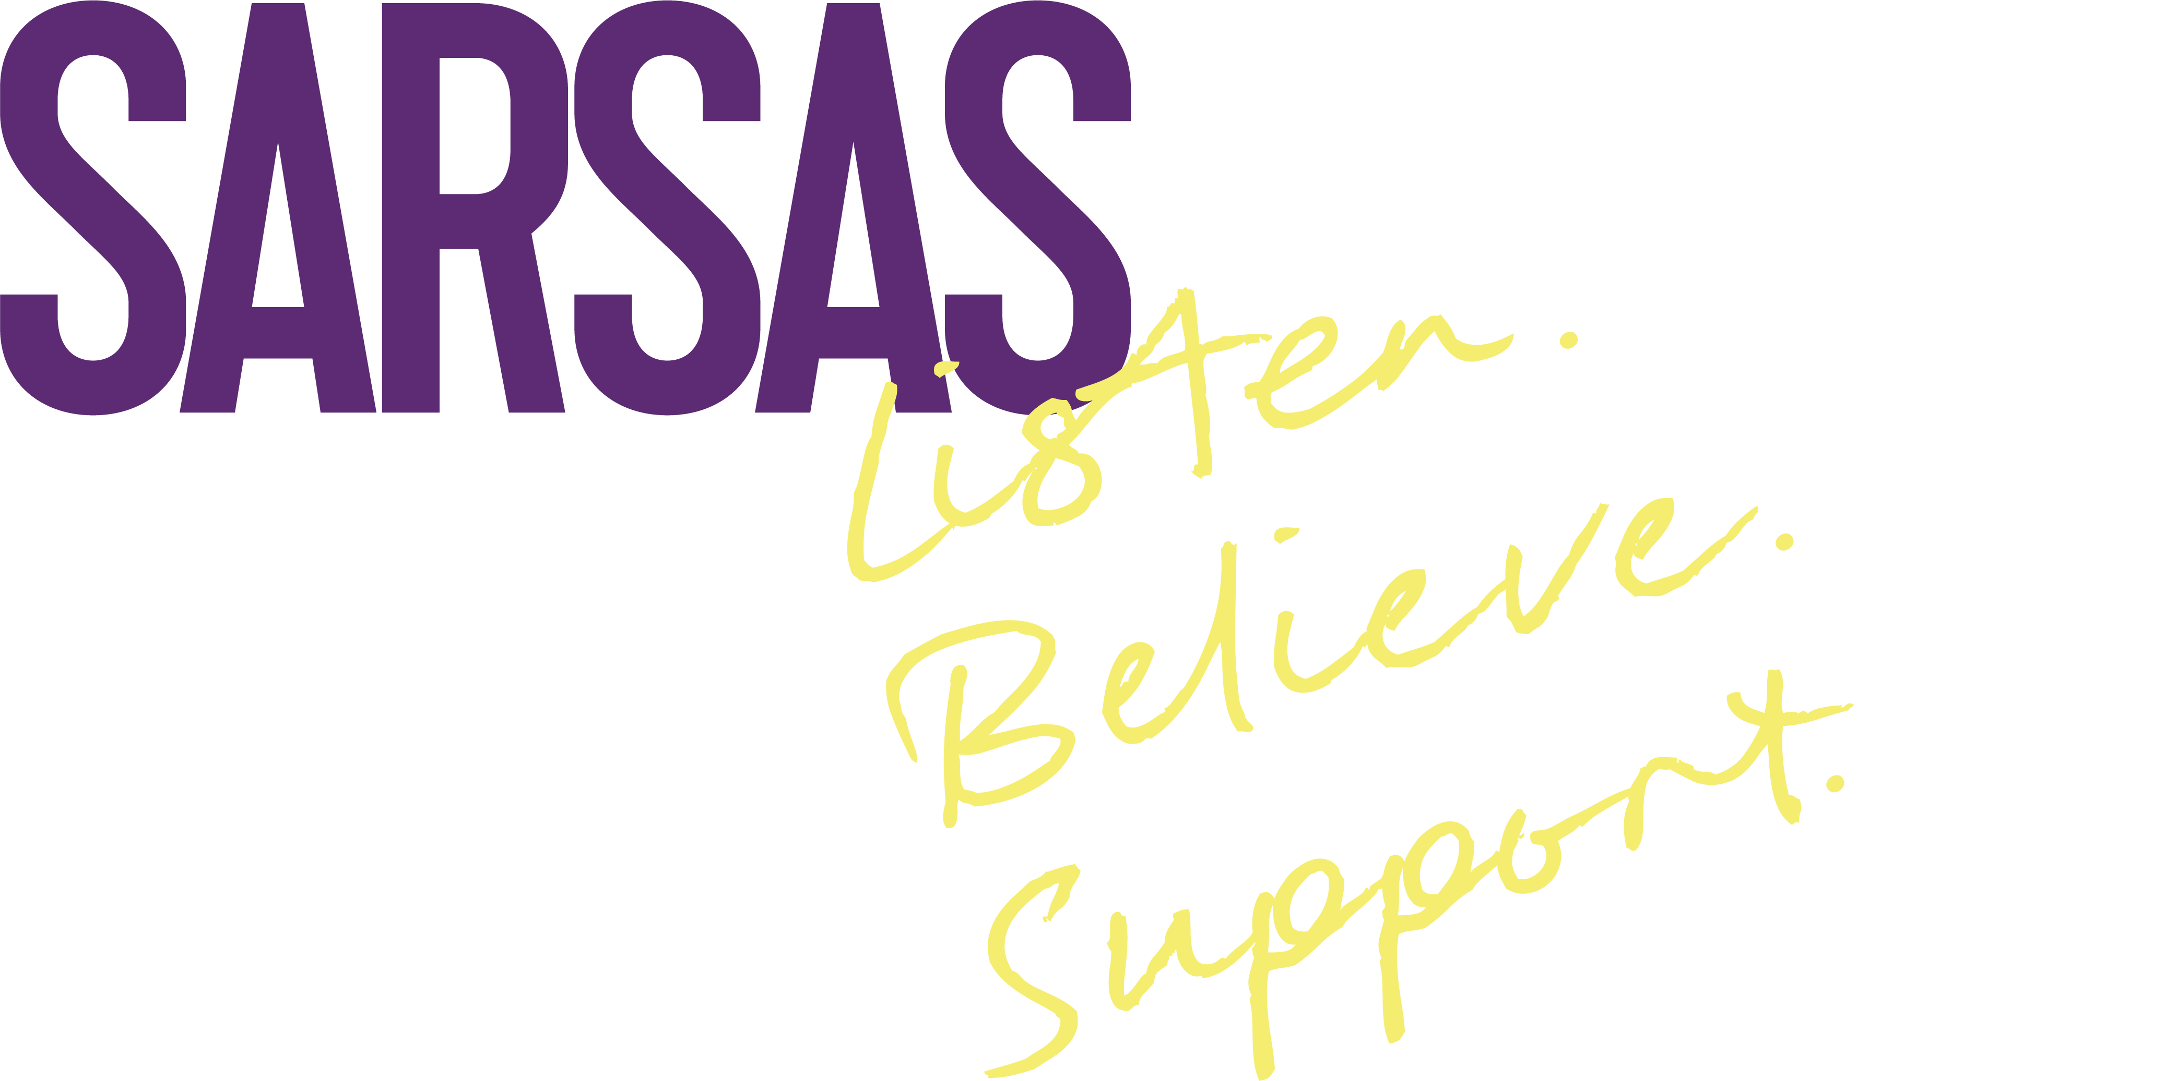

Helpline Volunteer Application Form

Thank you for your interest in volunteering with SARSAS. If you have any questions or need support filling out this form, please email volunteer@sarsas.org.uk.
Before filling out this form please ensure you can attend all the training sessions:
Fri 2nd February 2024 | Central Bristol | 10:00 to 17:00
Sat 3rd February 2024 | Central Bristol | 10:00 to 17:00
Fri 9th February 2024 | Central Bristol | 10:00 to 17:00
Sat 10th February 2024 | Central Bristol | 10:00 to 17:00

Personal Details

Name
Contact telephone number
Email
Address

Volunteering Availability

Please tell us when, and how, you would prefer to volunteer

Volunteers normally pick a session and stick to it each week, so it is not a problem if you can only do 1 slot.
Please delete slots you cannot do and let us know if you have a preference. We are particularly short on volunteers at the beginning of the week but welcome any commitment you can make.

Mon 10:45 –14:15
Tues 17:45 – 20:15
Wed 17:45 – 20:15
Thur 17:45 – 20:15
Fri 10:45 – 14:15

I would prefer to volunteer
- From my home (within Bristol, Avon and Somerset)
- At the SARSAS office in Central Bristol
Please delete your least preferred option

We strongly encourage applications from volunteers who have had previous experience of using sexual violence support services, including our own services. We do need to be satisfied that you have processed your own experiences sufficiently to support our callers in a way that is safe for everyone. You do not need to share any details of your experiences with us, but it would be helpful to know if you have used our services in the last few years and roughly when that was. (We will discuss with everyone at interview whether there are certain areas that you may find difficult or triggering on the helpline or that you would appreciate additional support around). *
*If you would prefer to talk to someone on the phone email volunteer@sarsas.org.uk and the Volunteer and Helpline Manager will give you a call.

About You
- Why would you like to volunteer with SARSAS? (~500 words)

- What qualities, skills and experience would you bring to the role of Helpline Volunteer? See Role Description for details of the role. (~500 words)

How did you find out about us?

Thank you for applying to volunteer with us and for giving us your time.
Useful information for you:

1. The next step in your application is for us to invite you in for an informal interview so that you and we can decide if this is the right role for you.

2. At this interview, we’ll talk more about training. Training dates are at the top of this form:

You must attend all the training days to go on to volunteer

3. If you are accepted as a volunteer, we will ask for two references, and for you to complete a DBS check.

What to do with your completed form:

Email it to volunteer@SARSAS.org.uk by Sunday 14th January 2024

Any personal information is gathered as part of our agreement with you as a volunteer so that we can contact you. The form will be saved in your personal file on the restricted access M Drive and any paper copies shredded. If your application is successful, the record will be held securely in your personal folder until six years after you leave SARSAS when it will be safely destroyed. If unsuccessful, it will be destroyed after one year.

