What to do if you want support?

You can call us at
Bristol office:
0117 929 9556
Taunton office:
01823 324 944

Or
email us at info@sarsas.org.uk
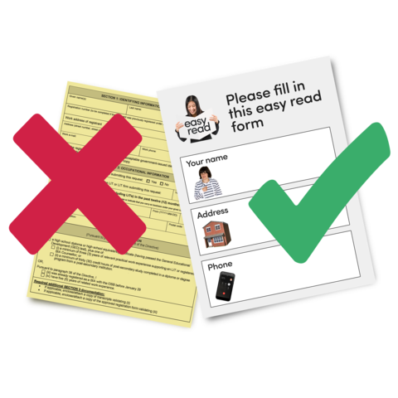 | Or  Fill in a form or ask someone you trust to fill in the form which is on our website www.sarsas.org.uk

