What support can I get?

 | We have a specialist service for women with learning disabilities and or Autism
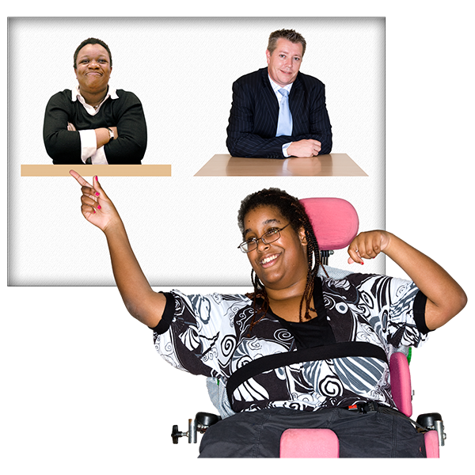 | We provide one to one specialist support work.  You will have a  support worker who will meet with you.  Your support worker can help you with things like:  - Managing your feelings  - Advocate for you (write letters, speak to other services)  - Give you information about other services.  - Talk about healthy relationships  - Support to build Confidence
 | Your support worker can support you for up to 6 months.
We also offer workshops and training.

We can talk about healthy relationships and consent.

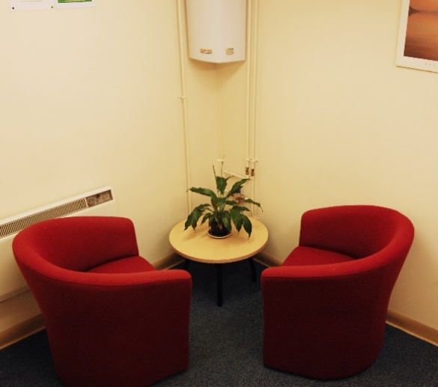 | We can also tell you more about counselling where you can talk about any bad things that have happened to you and think about feelings.

