Questions about support

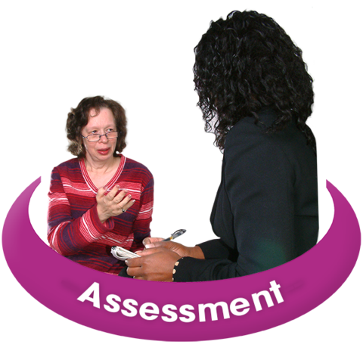 | What happens after I have contacted you?  We will contact you and arrange a time for an assessment.  At the assessment we will tell you more about the service. We will also find out a bit more about you.
 | When will I get a support worker?  When a space comes up, we will contact you. We have a waiting list. You might wait for about 6-9 months.
 | Can I bring someone with me?  You can bring someone with you to appointments. It might be nice for you to come to the sessions on your own, when you feel ready.
   | Where will we meet?  We can meet you in our office in Bristol or Taunton.  Or we can meet you virtually on the computer  Or we can contact you on the phone.
   | How long is the support for?  You will get support for up to 6 months.  After 6 months you and your support worker can think about other support that you might need like counselling or therapy, group work.
   | How long does a session last?  Your support worker will arrange a time to meet with you.  A session lasts for about 1 hour.
   | Can I talk to my support worker about what happened to me?  You can tell your support worker as much about your experiences as you like but your support worker isn’t a counsellor.  Your support worker work will help you to learn ways to have control over your life and be able to think positively about your future.
   | Will you tell anyone?  We will keep what you talk about confidential.  We will only share information about you if it is to keep you safe – this is called ‘safeguarding’.

