What if I need to talk to someone before I can get support?

At SARSAS we have a phone support helpline.
You can call if you want someone to talk to.

Phone: 0808 801 0456

The helpline is open
Monday & Friday
11am – 2pm
Tuesday, Wednesday, and Thursday
6pm – 8:30pm

Email support
support@sarsas.org.uk

We also have email support so you can write to us for help.

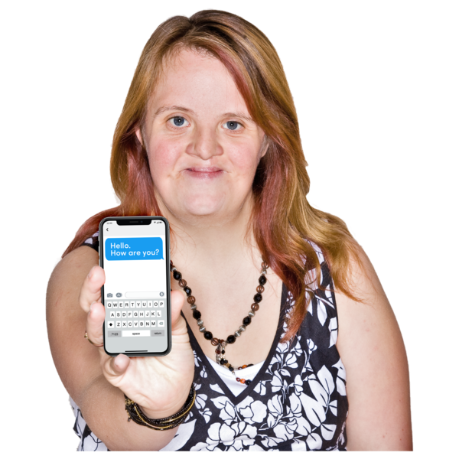 | Live Chat support  This is sometimes called text chat.  You can message us on live chat for help.  You can find this on our website www.sarsas.org.uk

