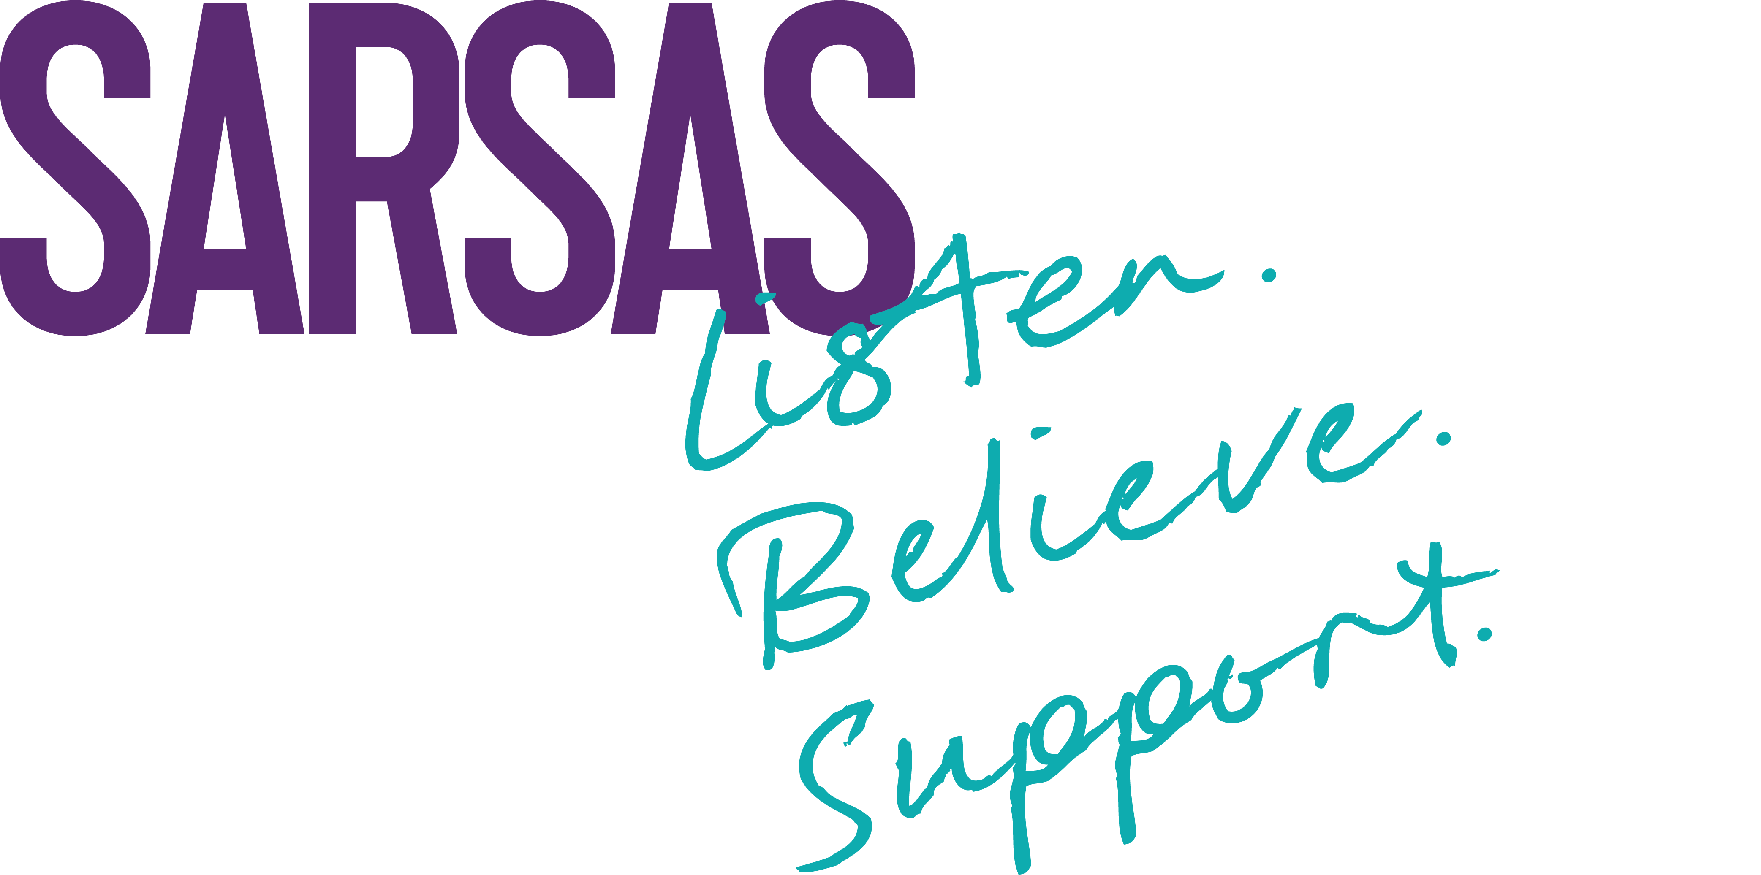

Equality and Diversity Monitoring Form

SARSAS is committed to equality and to actively seeking qualified candidates that contribute to the diversity of the organisation.
We are asking for the following information so that we can monitor and ensure that our recruitment and selection processes are free from bias and discrimination. The data we are asking for reflects the Equality Act 2010 requirement not to discriminate on the grounds of age, disability, ethnicity, gender identity, marital/civil partnership status, religion or belief, sexual orientation and pregnancy and childbirth.
The information you provide will be treated confidentially within the organisation. We assure you that this paper will be separated from your application before your application is considered and will not form part of the decision making process.
Thank you for completing this form.

Age

What is your age group?
16 – 17 18 - 24 25 – 34 35 – 44 45 – 54 55 – 64 65 - 74 75+
Prefer not to say

Disability

The Equality Act 2010 defines disability as:
“A physical or mental impairment which has a substantial and long-term adverse effect on a person's ability to carry out normal day-to-day activities.”
Do you consider yourself to be a disabled person?
Yes No Prefer not to say
If yes, please tick all that apply:
Physical / mobility impairment

Sensory impairment e.g. visual impairment, hearing impairment, speech impairment

Learning disability or difficulties, or cognitive impairment

Mental health condition e.g. schizophrenia, depression

Long term health condition e.g. HIV, diabetes, fibromyalgia

Other – please specify

Ethnicity
How would you describe your ethnicity?
A. White
British (including English, Welsh, Scottish, Northern Irish)
White Irish
White European
Any other White background
B. Mixed / Multiple ethnic groups
White and Black Caribbean
White and Black African
White and Asian
Any other Mixed background
C. Asian or Asian British
Indian
Bangladeshi
Pakistani
Chinese
Japanese
Any other Asian background
D. Black or Black British
Caribbean
African
Any other Black background
E. Other ethnic group
Arab
Any other ethnic background
F. Prefer not to say
G. Unknown

Religion or Belief
None |  | Muslim
Atheist |  | Sikh
Buddhist |  | Other
Christian
Hindu |  | Prefer not to say
Jewish |  | Unknown

Sexual Orientation
Heterosexual |  | Other
Lesbian or Gay Female |  | Prefer not to say
Bisexual

Relationship Status
Married or in a Civil Partnership |  | Single / Relationship
Divorced |  | Prefer not to say
Separated |  | Unknown

Gender identity
Is your gender identity the same as the gender you were assigned at birth?
Yes No Prefer not to say

Caring responsibilities
Are you caring for a child 6 months or under? Yes No Prefer not to say
Are you caring for other children? Yes No Prefer not to say
Have you other caring responsibilities? Yes No Prefer not to say
Are you pregnant? Yes No Don’t know Prefer not to say

